**I have been working on a startup to offer bilingual courses,**

**In 2021, I was invited to give a Workshop at a very prestigious institute in India. I was there online for two days. At that time, I was teaching Data Mining and my TA was Pralobh, I started developing a course that I could offer to students in India. He said it is Awesome and we did. Hope, you like it.**

**Diaz and Pralobh**

**First data mining Assignment**

Steps

1. <https://www.nesheracademy.com/pages/login-new> click on the red button.

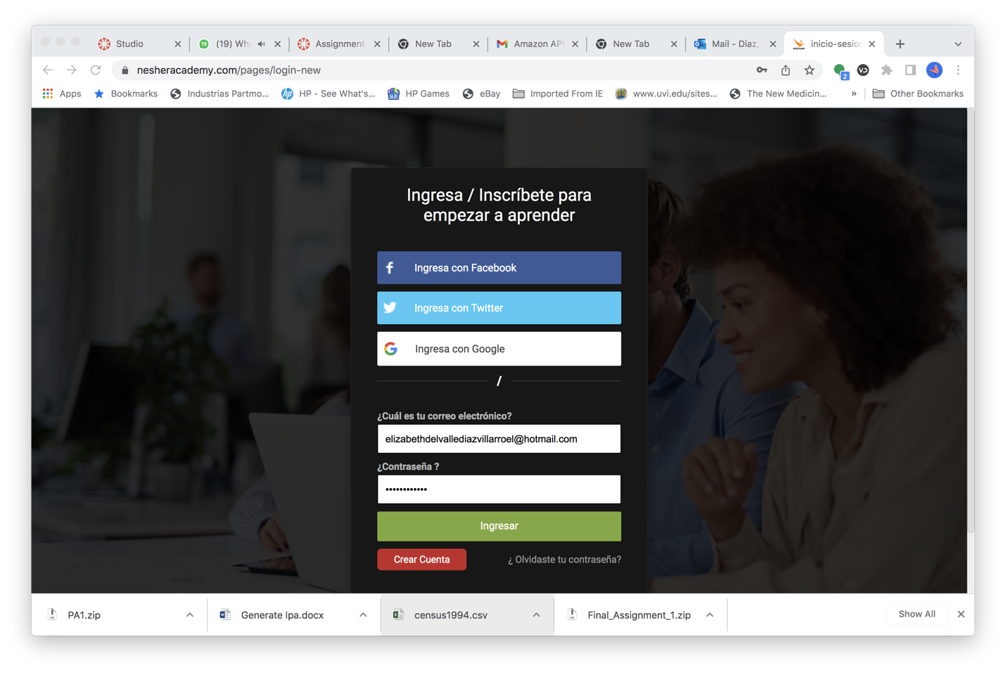

1. Fill out this form

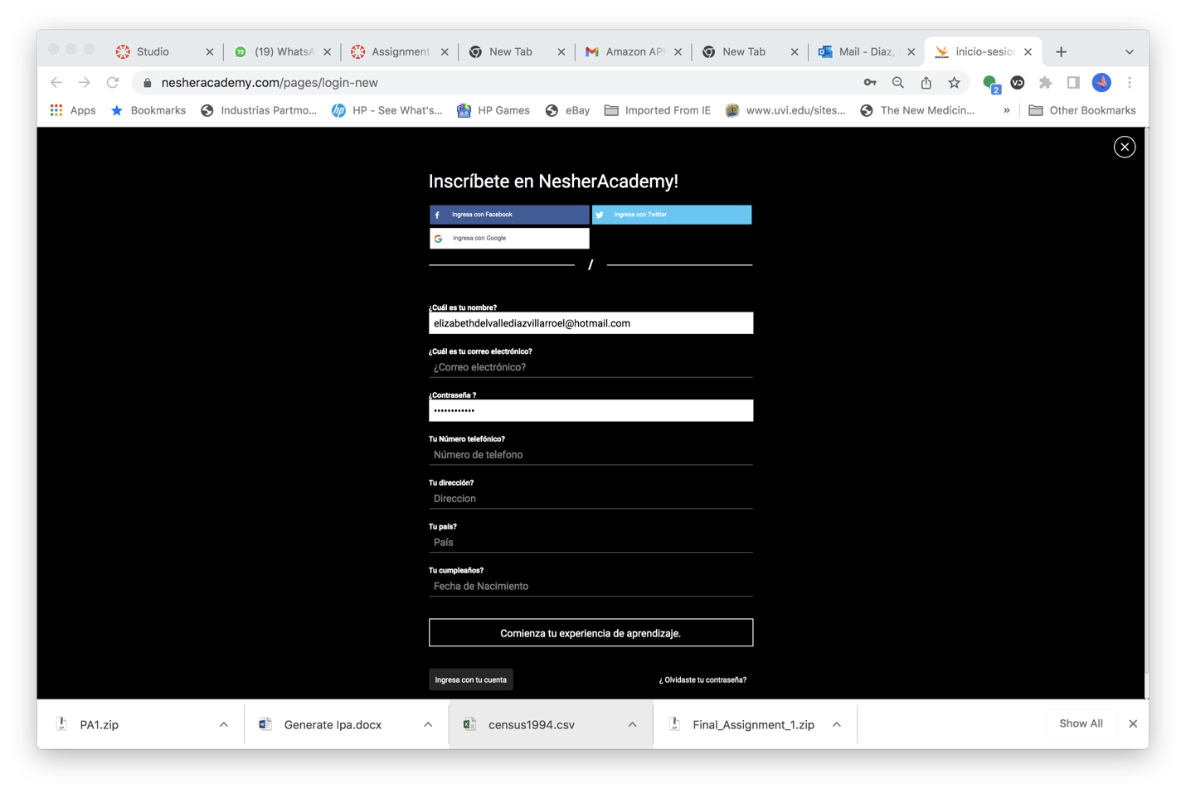

First field is your name, second one is your email, password and click on the button

Once you have an account, you are to go to our course:

